**Mathematics in the 21st Century**

**Lecture Five: The art of maths**

**Chris Budd OBE, University of Bath, UK**

**Gresham Professor of Geometry**

March 10th, 2020

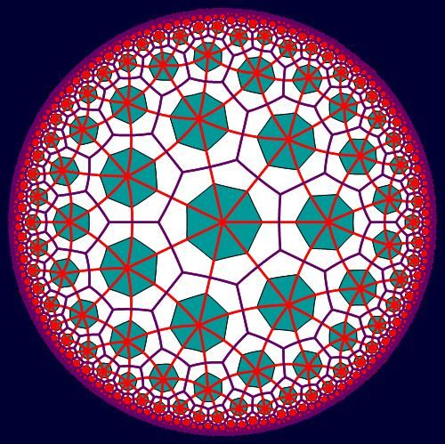

**1. Introduction**

Maths and art have much in common. Both are intensely creative, both have a strong abstract nature, both are highly creative, and both are driven by the search for beauty. An often asked question is whether maths is and art or a science. In practice it shares aspects of both, and it is a shame that the more ‘artistic’ aspects of maths are often not emphasised more in the way that maths is taught. (If it was I am convinced that many more young people would appreciate the creative side of mathematics). Whole conferences, such as the Bridges Conference [??] and the Origami Society for Mathematics, are devoted to the role of mathematics. Mathematics has been involved with art from the earliest days, from the Sona diagrams from sub Saharan Africa, to the perspective of the Renaissance, and from Islamic geometrical designs, to the wonderful work of Escher. Indeed, we all experience the interplay between mathematics and art in our lives, whether it is in the pattern of the wallpaper on our walls, or the style of our favourite knitted jumper.

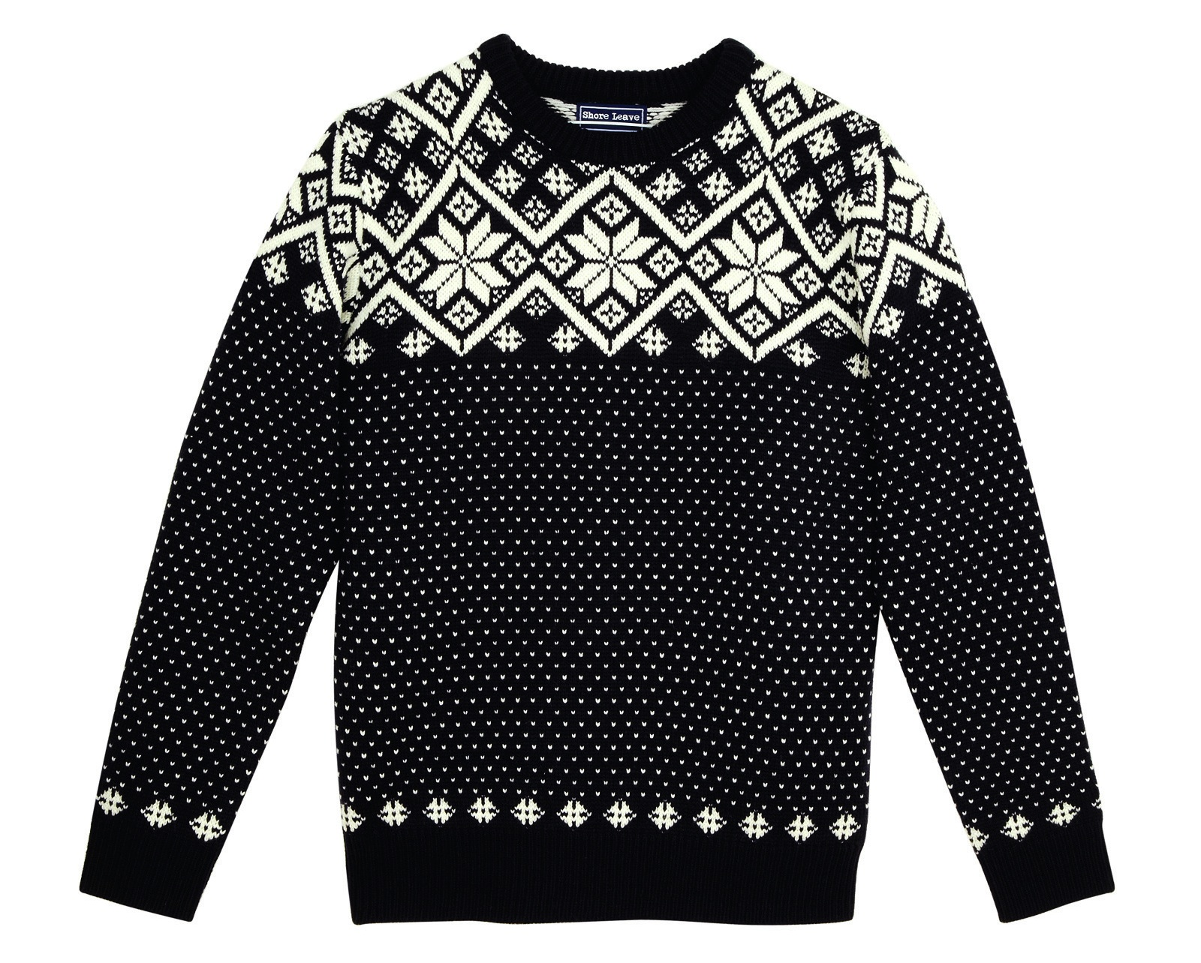

In this lecture we will take a look at many of the aspects of mathematical art mentioned above. We will also conclude the lecture with a little bit of mathematically inspired dancing (which you will have to do at home if you are reading this transcript). I hope that at the end of it, you will truly appreciate what a creative, and beautiful subject, that mathematics really is!

**2. Celtic and Sub-Saharan African Art**

**2.1 Celtic Art**

**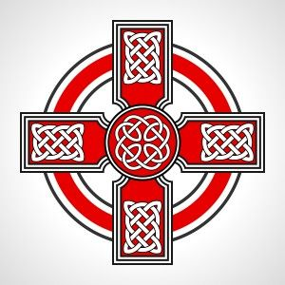**

One of the earliest examples of geometrically inspired art comes from the Celtic artistic tradition, especially the drawing of Celtic Knots. This tradition dates back to ???? both as a popular art form, and also through the illustration of sacred texts in monasteries and churches. These designs look extremely intricate, and indeed took a long time to create by the monks, but they are all based on sound mathematical principles. Once these principles are mastered, not only can you recreate the original Celtic designs, you can also design your own. Even if you have no artistic talent.

**< Bit more on the history here >**

**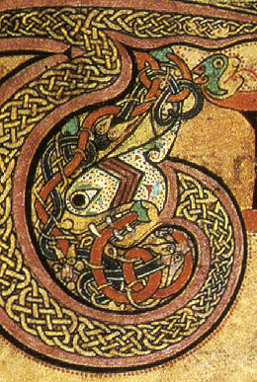**

Below we can see the letter T from the title page of John’s Gospel in the celebrated *Book of Kells.* This masterpiece was written at around 800AD in Ireland and is an early version of the Gospels. It was richly illustrated, as can be seen below. It is not quite clear what the illustrated animal is, with various theories ranging from a snake to a lion, neither animal being native to Ireland. What is of main interest to us is the art work inside the animal, which is a nice example of a Celtic Knot.

The designs seen in Celtic Art very often take the form of knots, or links. A *knot* is a design formed from one piece of string, usually with its ends joined together. A *link* is a design made up of several pieces of string, again with their ends joined together. The general theory of knots is a rich (and difficult) are of modern mathematics. Examples of knots are given below, with the complexity of the knot increasing with the number of crossings. The knot with three crossings is often called the *trefoil knot* and is a frequent image in both Celtic art and the art of many other cultures. One reason for this is that it is the simplest knot which cannot be untied. The familiar reef knot, often used to tie two pieces of strong together, is just two trefoil knots added together. Below is a lovely sculpture of a trefoil knot by John Robinson at Bangor University. The other knots with a small number of crossings (up to five) have a pleasing symmetry, which leads to them also being f0und in a lot of Celtic art. After that the general knot design becomes more complex and is less often seen in art. One of the most challenging problems in mathematics involves classifying all of the possible types of knot with a given number of crossings.

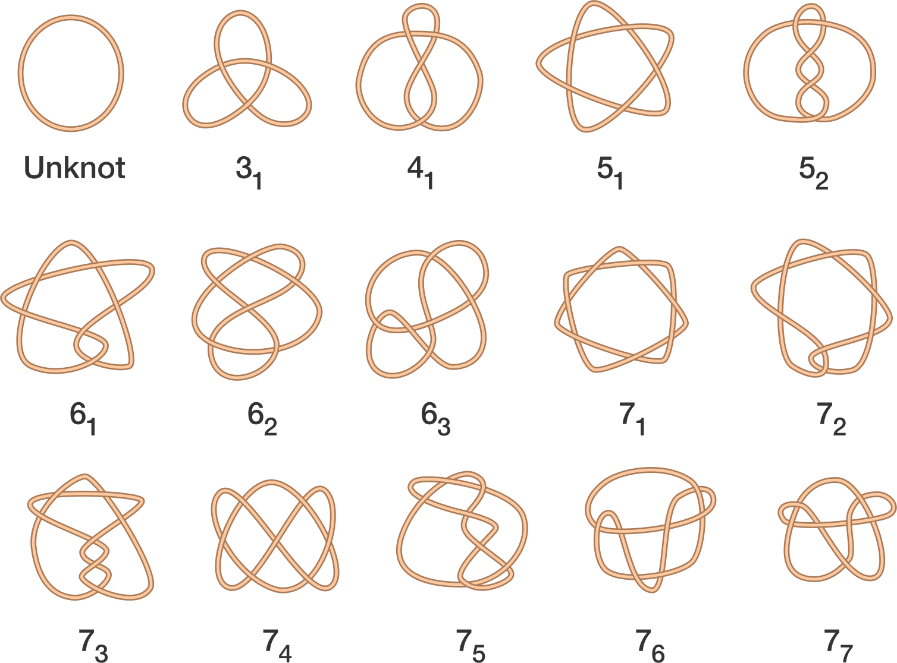

**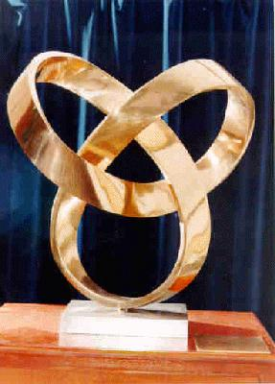**

The most common form of knot observed in Celtic art is the ‘under and over’, or alternating, knot. In this design the ‘string’ alternates between passing above, and then below, the others . An example of a link, which takes this form, is given below. This link is made up of four different intertwined loops. The under and over design both looks good, and reduces the number of possible types of knot with a given number of crossings.

**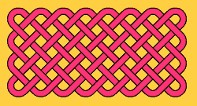**

One way to construct a (relatively simple) under and over knot is to start with a grid of squares:

|  |  |  |
| --- | --- | --- |
|  |  |  |
|  |  |  |
|  |  |  |
|  |  |  |

Any grid will do. We will give the grid a classification **(m,n)** which means that it is made up of m vertical lines and n horizontal lines. Different values of m and n lead to different types of knot or link. The above is a (5,4) grid. Below is a (6,5) grid. The knot/link on this grid is started by placing crosses on the horizontal mid-points as indicated. Note the direction of the over and under crosses.

**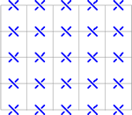**

The next stage is to place crosses on the vertical lines, with the under and over crosses going the other way.

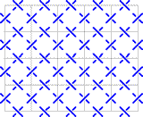

Finally you join up the crosses, with right angle turns at the sides and U-turns at the corners.

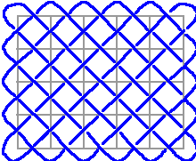

The result is either a knot or a link. What you get depends on the type of grid that you use. The patterns that arise closely resemble fishing nets, and we can count the number of pieces of string that are needed to make them. There is close link between the number of pieces of strong and the form of the grid. Here are some examples:

|  |  |  |
| --- | --- | --- |
| **m** | **n** | **Number of strings** |
| **5** | **6** | **1** |
| **2** | **2** | **2** |
| **3** | **4** | **1** |
| **3** | **6** | **3** |
| **4** | **4** | **4** |

It is an interesting challenge to find a rule which links the pair (m,n) to the number of strings. Doing this is a useful introduction to how maths can be done (at least this is the way that I, and many others, do it). I would describe this as follows:

1. Do lots of experiments
2. Look for patterns
3. Make a hypothesis
4. Check your hypothesis with lots of other examples
5. Prove your result using mathematical reasoning.

The first four of these represent the scientific method. It is number 5 which distinguishes mathematics from science. Many of my mathematical colleagues also omit item 1 on this list.

After some experiments you should some up with the hypothesis that the number of strings are given by the **greatest common divisor of the two numbers m and n, gcd(m,n).** Which is the largest number which divides both m and n. So gcd(2,7) = 1 and gcd(2,8) = 2. It really does work, and you can test it (by drawing) on many examples.

Proving this result is actually quite hard. You do it by successively reducing the size of the problem, whilst keeping the same number of strings. The proof is actually a geometrical version of the celebrated Euclidean Algorithm for finding gcd(m,n). This is one of the first recorded algorithms, and was described in Euclid’s elements in 300BC. It is still in use today, in areas such as cryotograpy, error correcting codes and predicting eclipses. Euclid’s algorithm uses the fact that

gcd(m,n) = gcd(m,n-m)

or in other words the number of pieces in an (m,n) grid is the same as in an (m,n-m) grid. Try showing this yourself.

True Celtic art of course uses much more complex patterns than those described above. Here is an example

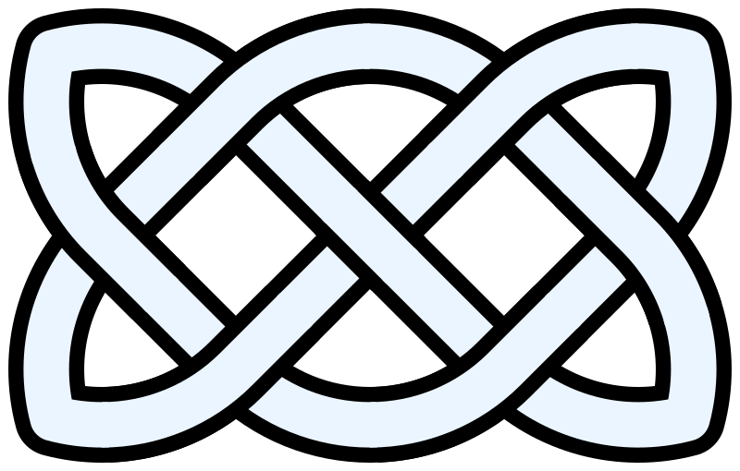

Despite looking complex, most of these designs can be constructed by using a succession of simple rules. See below for a guide to how to do this..



Different knots can be created by taking different grids (even circular grids will work, or even grids in the tail of a snake) and by choosing different combinations of the knot crossing designs A,B and C for the corners. The knot above is an AAA design. In fact for a grid as above we can make an algebra of 27 knots by looking at the different types of arrangement. For example AAA, AAB, AAC, ABA, .. all give different knots. Once the arrangement has been decided, drawing the knot is straightforward. Try it for yourself. It is easy to go from a mathematical arrangement to a beautiful Celtic knot design

**2.2 Plaited Mat Sona Art**

The Sona art traditions of sub-Saharan African art predates Celtic art, and produces striking patterns of great complexity and power, which have similar mathematical structures to the Celtic patterns. Sona patterns are mainly found in Angola and Mozambique, and are traditionally drawn with fingers in the sand. These patterns are beautifully described, and their mathematical properties studied, in the wonderful book [??].

**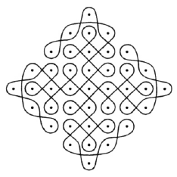**

**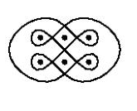**

**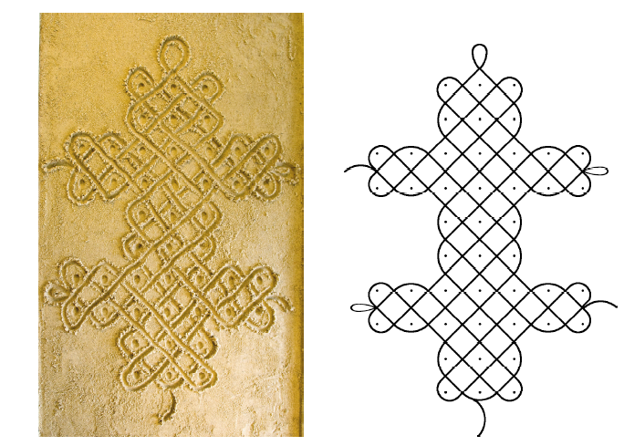**

**Basic Sona Plaited Mat Patterns**

The Tchokwe people of south-central Africa have a tradition of storytelling using Sona, as memory aids. Typically these drawings would be traced in the sand winding around a rectangular grid of finger dots, again by using a finger, while telling the tale. Ideally the entire figure would be traced without having to remove the finger from the sand so that the entire diagram is constructed with a single curve that does not retrace itself. This is called a mono-linear curve. One of the simplest types of Sona is called the plaited mat design. This starts with a regular, rectangular, pattern of dots. Then a curve is drawn at 45 degrees to these dots. The edge of the rectangular grid then behaves like a mirror with lines hitting the mirror and rebounding at 45o . At the corners, the curve does (another) U-Turn. Here are two examples:

**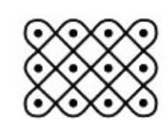**

**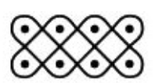**

Just as in the case of the Celtic Knot patterns we can classify the plaited mat designs by the two-dimensional arrangement (m,n) of the dots. On the left is a (3,4) design, and on the right a (2,4) design. We can then ask the question of how many times we have to trace over the figure to get the design (that is how many times we have to list off our figure when doing the drawing). In fact we already know the answer. The number of loops L that we need is (as before)

L = gcd(m,n).

Thus we get the desired mono-linear design if gcd(m,n) = 1, so that m and n are *co-prime*.

The pictures above also show a high degree of symmetry, which is one reason that they have such a beautiful form.

**Lion’s stomach**

There are many examples of different, and more complex, Sona patterns, which display a high degree of symmetry. Below is the Lion’s stomach design.

**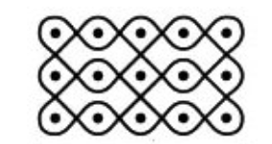**

**Chased Chicken**

Another design (in fact my personal favourite) is the Chased Chicken design.

**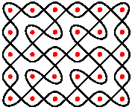**

**3. Islamic art, wallpaper, tilings, and quilt patterns**

In contrast to sub Saharan Africa, the North of Africa, in particular those countries associated with the Islamic faith, give a very different, and a very lovely, example of mathematically inspired art. The Islamic faith was founded in ??? and provided laws to govern both religious observance and also social behaviour. While the Qur'an contains no specific prohibition on making images of people or animals, most interpretations of the Islamic law have tended to discourage any such imagery as potentially idolatrous, leading from an exclusion of these from most religious settings. As a result, Islamic art developed in the directions of abstraction and geometry, with the result being some very beautiful, geometrically inspired, patterns. This use of geometry is also thought to reflect the language of the universe (which is true of course) and help the believer to reflect on life and the greatness of creation.

These geometrical patterns have now been developed (often by mathematicians) into tiling patterns and patterns on quilts, and we will have a look at all of these in this section.

**3.1 Geometry in Islamic design**

Here are some excellent examples of Islamic art.

**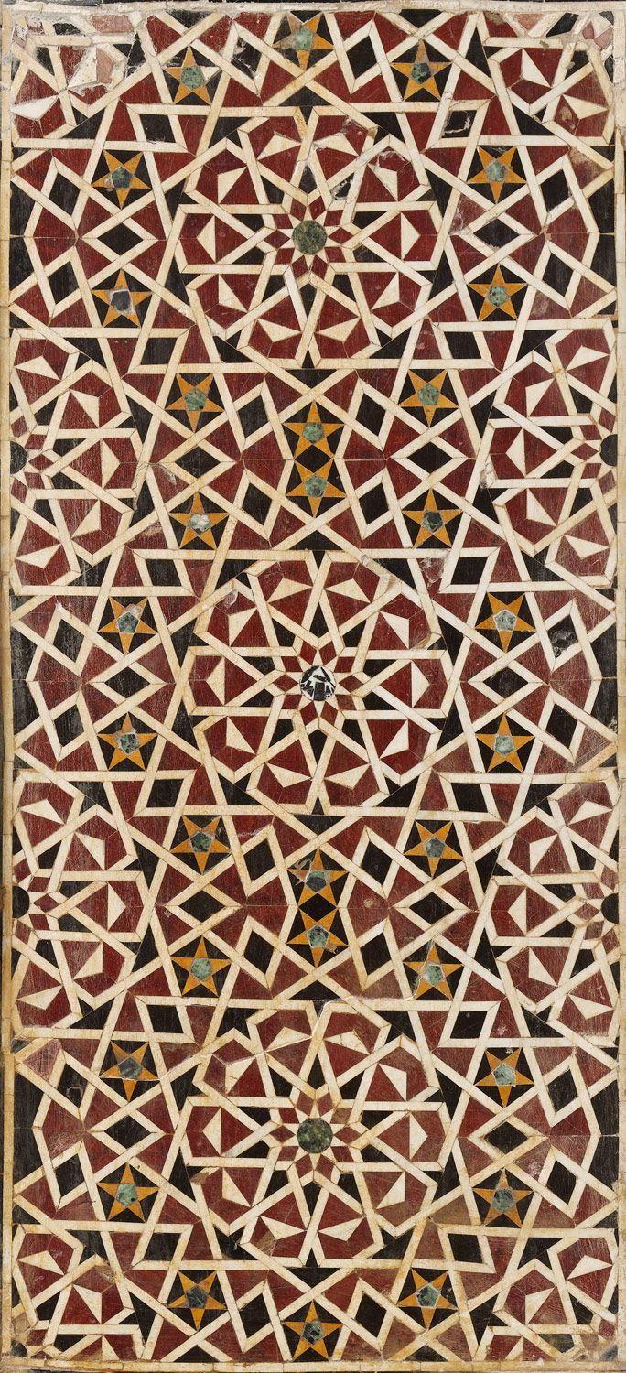**

**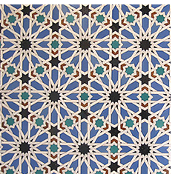**

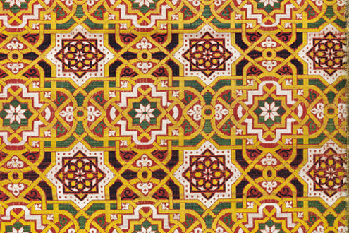

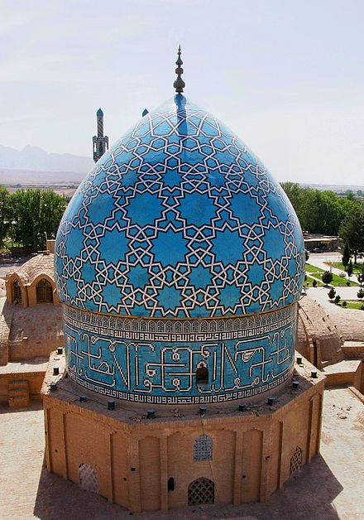

(The Shah Nematollah Vali Shrine. This combines 5,7,9,12,11,9 and 10 points in turn.)

Among the most important aspects of Islamic geometric design are repetition and variation. A series of tiles, for example, may consist of only one or two basic shapes but the patterns of the tiles may all be different and the shapes are then combined to create a complex interlocking pattern. Examples of some of the repeated designs are given below. They are frequently constructed by using the ruler and compass constructions, used by the Greeks as a foundation of their goemetry

**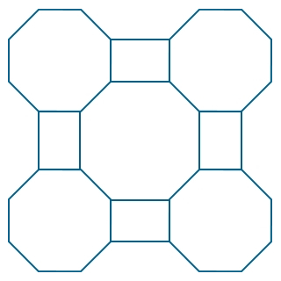**

**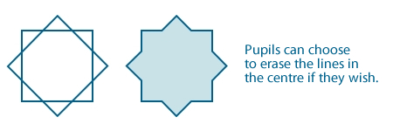**

Further information on both the history of Islamic art, and how to use a ruler and compass to construct the designs is given in the article [??] by Alex Bellos.

Symmetry also plays a part in most Islamic patterns. There may be a single line of reflexion symmetry, usually from the top to the bottom, or there may be three or four lines of symmetry. Translational and rotational symmetry are also used, and are frequently combined in the same design.

This leads us naturally to the concept of a Euclidean symmetry E2, which are the transformations of the plane which preserves distances. So that if x is a point in the plane then g(x) is where it ends up after the action of the symmetry. Euclidean symmetries are either

Translations: g(x) = a + x

Reflexions: g(x) = -x

Rotations: g(x) = Mx where M is a *rotation matrix*

Or a combination of these.



An Islamic art pattern is a special case of a *Wallpaper Pattern*. An example of one of these is given below.

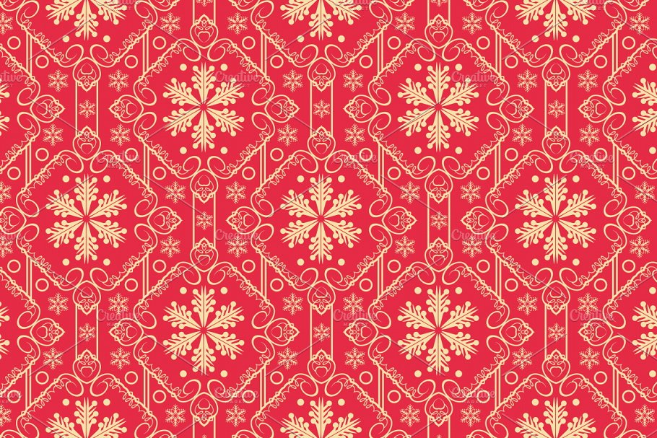

A wallpaper pattern is simply a repeating pattern on the plane, which is unchanged under the action of some of the Euclidean symmetries, such as a rotation or a translation in some direction. A *wallpaper group* is a subgroup of E2 which leaves that wallpaper pattern unchanged.

Remarkably, it was shown in 1891 that there are exactly **17 types of wallpaper group**. Of these five are typically seen in Islamic art. The basic types are seen below, taken from [??].

**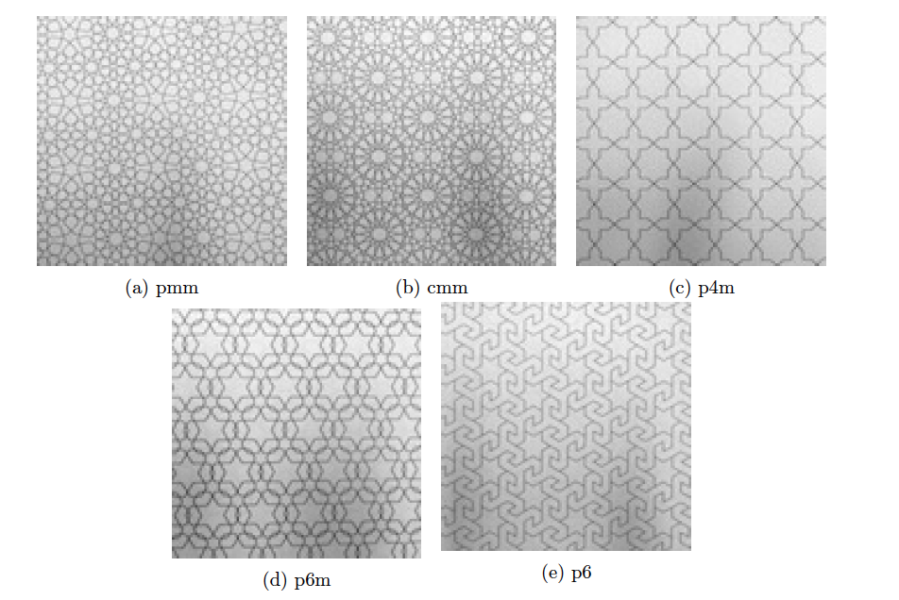**

Examples of wallpaper patterns for each of the 17 wallpaper groups (taken from [??]) are given below

**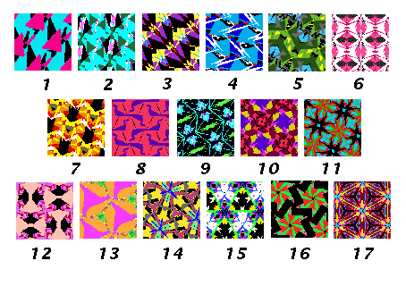**

**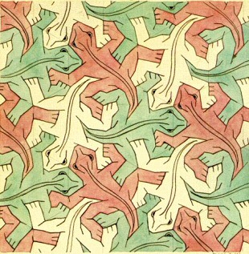**

**1943 Repitles**

**4. Renaissance art and perspective.**

**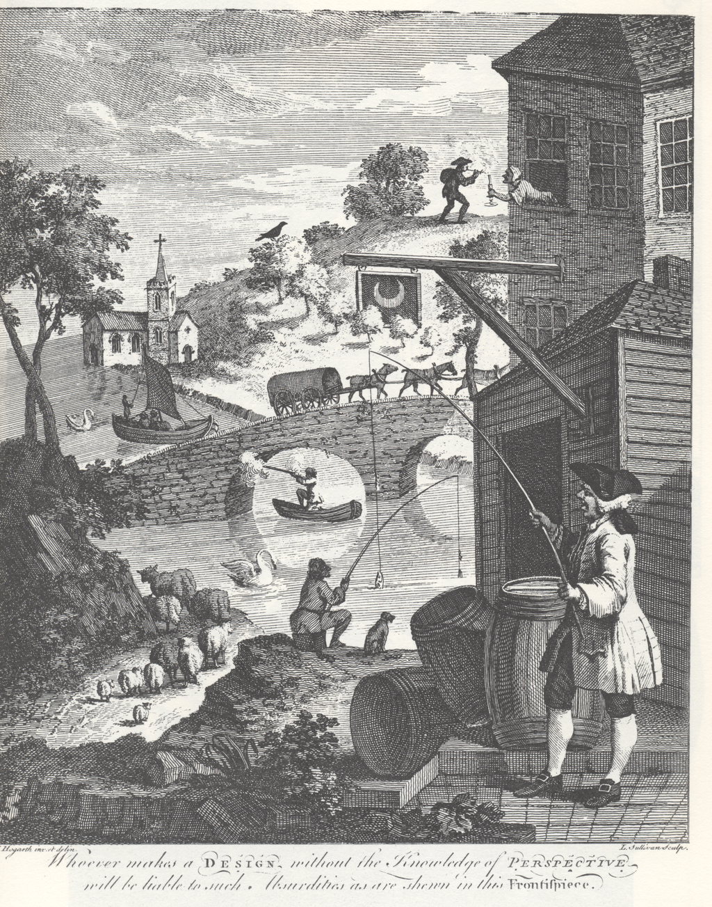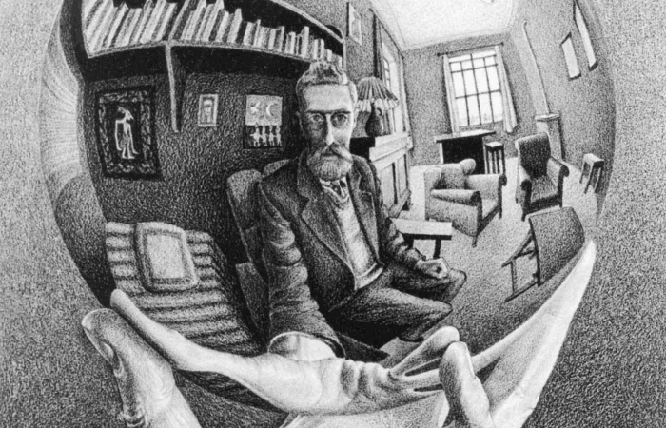**

**Projective geometry**

**5. Escher and Fractals**

One of the most interesting artists of the 20th Century was M.C. Escher (1898-1972). His pictures are known by nearly everyone. Many of them display a striking mathematical form, in which Escher explores some deep mathematical ideas. A major reason for this is that Escher was strongly influenced by several great mathematicians including, George Polya, Harold Coxeter and also Roger Penrose, who we met in the last section. Further mathematicians have carried on Escher’s great legacy, most especially Hendrik Lenstra from the University of Leiden. His work features mathematical objects and operations including [impossible objects](https://en.wikipedia.org/wiki/Impossible_object), explorations of [infinity](https://en.wikipedia.org/wiki/Infinity), [reflection](https://en.wikipedia.org/wiki/Reflection_(mathematics)), [symmetry](https://en.wikipedia.org/wiki/Symmetry), [perspective](https://en.wikipedia.org/wiki/Perspective_(graphical)), [truncated](https://en.wikipedia.org/wiki/Truncation_(geometry)) and [stellated polyhedra](https://en.wikipedia.org/wiki/Stellation), [hyperbolic geometry](https://en.wikipedia.org/wiki/Hyperbolic_geometry), and [tessellations](https://en.wikipedia.org/wiki/Tessellation). Although Escher believed he had no mathematical ability, he interacted with the mathematicians [George Pólya](https://en.wikipedia.org/wiki/George_P%C3%B3lya), [Roger Penrose](https://en.wikipedia.org/wiki/Roger_Penrose), [Harold Coxeter](https://en.wikipedia.org/wiki/Harold_Scott_MacDonald_Coxeter) and [crystallographer](https://en.wikipedia.org/wiki/Crystallography) [Friedrich Haag](https://en.wikipedia.org/wiki/Friedrich_Haag), and conducted his own research into [tessellation](https://en.wikipedia.org/wiki/Tessellation).

Inspired by the Islamic tessalations above

Escher's work is inescapably mathematical. Sadly This has caused a disconnect between his full-on popular fame and the lack of esteem with which he has been viewed in the art world. His originality and mastery of graphic techniques are respected, but his works have been thought too intellectual and insufficiently lyrical. Movements such as [conceptual art](https://en.wikipedia.org/wiki/Conceptual_art) have, to a degree, reversed the art world's attitude to intellectuality and lyricism, but this did not rehabilitate Escher, because traditional critics still disliked his narrative themes and his use of perspective. However, these same qualities made his work highly attractive to the public.[[21]](https://en.wikipedia.org/wiki/M._C._Escher#cite_note-Locher13-23)

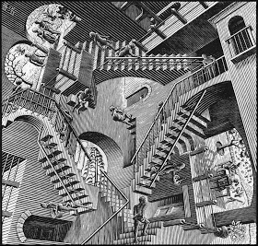

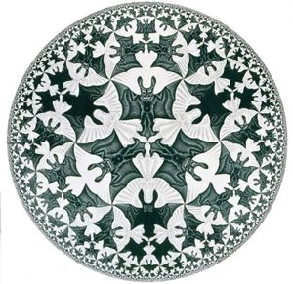

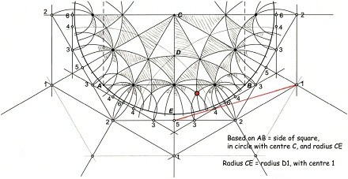

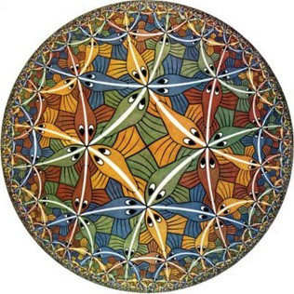

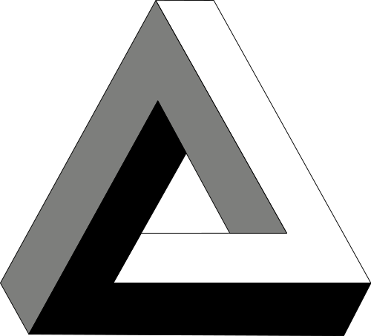

To achieve visual balance, Escher insisted that the shrinking patterns converge towards a circular boundary. The patterns emerge “like rockets”, in his words, and flow along curved trajectories until they “lose themselves” again at the boundary. Constructing this sequence required help from mathematics. After several attempts, Escher found the solution in an article written a few years earlier by the geometer Harold Coxeter.

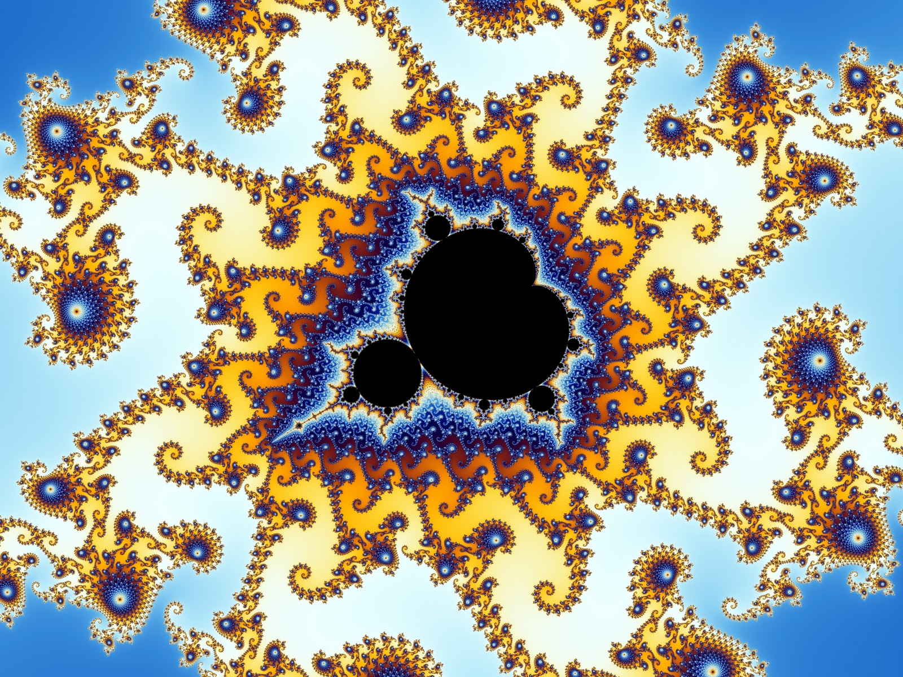

Use of mathematical ideas

Hyperbolic geometry

In 1956 the Escher made an unusual lithograph with the title Prentententoonstelling. It shows a man standing in an exhibition gallery, viewing a print of a Mediterranean seaport. What is remarkable about this picture is that we see simultaneously both the inside and the outside of the gallery. Escher used a mathematical approach to construct the picture, but he was unable to take it to completion, and the result was a blank circle in the middle. This picture is illustrated below.

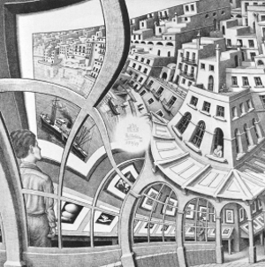

The immediate question on looking at this picture (once you have got over its striking visual form) is: what goes inside the hole?

Escher based his picture on the following grid:

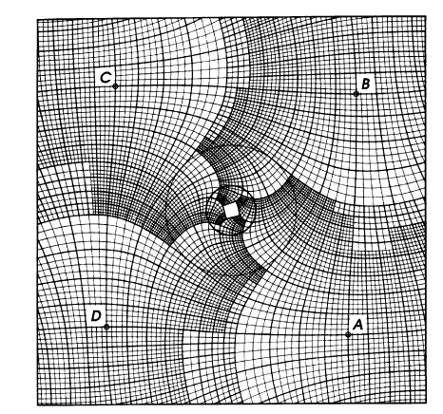

This grid has the property that as you travel from point A to D, the squares making up the grid expand by a factor of 4 in each direction. As you go clockwise around the center, the grid folds onto itself, but expanded by a factor of 256.

Escher then started with a picture on a regular grid as shown below.

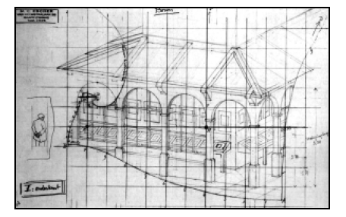

This was then mapped, square by square, onto the distorted grid to give the picture that Escher created. However his grid had a square in the middle which prevented him from completing the picture.

Not willing to see the picture incomplete, a group of Dutch mathematicians determined a map in the complex plane which corresponded to Escher’s curved grid. By extrapolating this map backwards they could then also continue the picture backwards, and by doing so were able to fill in the hole. The result is presented below. If you look carefully you can see the image repeating itself an infinite number of times as it goes into the hole. Small wonder that Escher did not try to complete it!

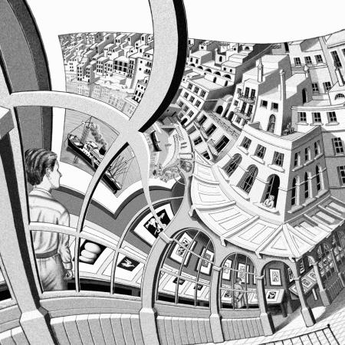

Despite wide popular interest, Escher was for a long time somewhat neglected in the art world; even in his native Netherlands, he was 70 before a retrospective exhibition was held.[[41]](https://en.wikipedia.org/wiki/M._C._Escher#cite_note-Poole-44)[[g]](https://en.wikipedia.org/wiki/M._C._Escher#cite_note-68) In the twenty-first century, major exhibitions have been held in cities across the world.[[62]](https://en.wikipedia.org/wiki/M._C._Escher#cite_note-ArtDaily-69)[[63]](https://en.wikipedia.org/wiki/M._C._Escher#cite_note-NGAWhatson-70)[[64]](https://en.wikipedia.org/wiki/M._C._Escher#cite_note-Treviso-71) An exhibition of his work in Rio de Janeiro attracted more than 573,000 visitors in 2011;[[62]](https://en.wikipedia.org/wiki/M._C._Escher#cite_note-ArtDaily-69) its daily visitor count of 9,677 made it the most visited museum exhibition of the year, anywhere in the world.[[65]](https://en.wikipedia.org/wiki/M._C._Escher#cite_note-72) No major exhibition of Escher's work was held in Britain until 2015, when the [Scottish National Gallery of Modern Art](https://en.wikipedia.org/wiki/Scottish_National_Gallery_of_Modern_Art) ran one in [Edinburgh](https://en.wikipedia.org/wiki/Edinburgh) from June to September 2015,[[63]](https://en.wikipedia.org/wiki/M._C._Escher#cite_note-NGAWhatson-70) moving in October 2015 to the [Dulwich Picture Gallery](https://en.wikipedia.org/wiki/Dulwich_Picture_Gallery), London.[[60]](https://en.wikipedia.org/wiki/M._C._Escher#cite_note-Dulwich-65) The exhibition moved to Italy in 2015–2016, attracting over 500,000 visitors in Rome and Bologna,[[64]](https://en.wikipedia.org/wiki/M._C._Escher#cite_note-Treviso-71) and then [Milan](https://en.wikipedia.org/wiki/Milan).[[66]](https://en.wikipedia.org/wiki/M._C._Escher" \l "cite_note-Milan-73)[[](https://en.wikipedia.org/wiki/M._C._Escher#cite_note-74)

**6. Dancing with maths**

Dancing is a wonderful visual art form, and maths has much to say about it. Indeed, by using a bit of maths we can design some really great dances.

Dancing has many forms, from the elegance of the waltz to the energy of the Ceilidh, and from the beauty of the ballet to the anarchy of Morris dancing.

**References**

[1] Journal Article

The 17 plane symmetry groups David Joyce

https://www2.clarku.edu/faculty/djoyce/wallpaper/seventeen.html

# Muslim rule and compass: the magic of Islamic geometric design

[Alex Bellos](https://www.theguardian.com/profile/alexbellos)

https://www.theguardian.com/science/alexs-adventures-in-numberland/2015/feb/10/muslim-rule-and-compass-the-magic-of-islamic-geometric-design

# Exploring Angolan Sand Drawings (sona): Stimulating Cultural Awareness in Mathematics Teachers

Paulus Gerdes

The Radical Teacher

No. 43 (Fall 1993), pp. 18-24

Published by: [University of Illinois Press](https://www.jstor.org/publisher/illinois)

https://www.jstor.org/stable/20709758

Page Count: 7

https://en.wikipedia.org/wiki/Wallpaper\_group

Artful Mathematics: The

Heritage of M. C. Escher

Lenstra Notices of the AMS 2003

Chris Budd, March 2020